Dr Sydney Domville Rowland

“A cheery, erratic creature with a vivid zest in life”

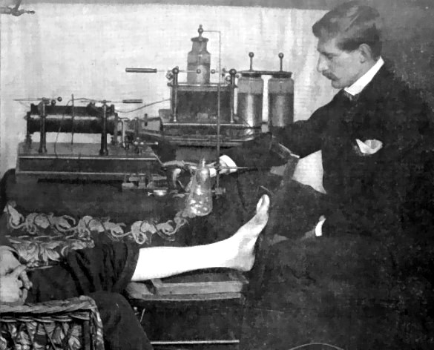

World’s first editor of an X-ray journal, 1896

The men of Stoke sub Hamdon who lost their lives during the 1st World War are commemorated on a hamstone monument clearly visible for miles, on the top of Ham Hill, where the golden coloured hamstone has been quarried since pre-Roman times. The name of Dr Rowland is not carved on the monument. By the time the monument was erected in the 1920’s, Dr Rowland’s father, vicar of Stoke, had moved away from the village. Dr Rowland is mentioned only on the Roll of Honour in the parish church. Sydney Domville Rowland is a man who deserves to be remembered, however, both in the village where he lived as a boy and further afield.

He was born in Cornwall in 1872, son of the Reverend William John Rowland who became the vicar of Stoke sub Hamdon in 1884, at the time when the Powys family occupied the vicarage of nearby Montacute. The Rowland family moved about a good deal during Sydney’s early years, two different parishes in Cornwall, then leaving for India in 1873 where the reverent Rowland worked in Jubbalpore, Calcutta Cathedral, Roorkee, Merrut, Fort William and Darjeeling. Sydney, the eldest boy of a family of four children, was sent to Berkhamsted Grammar School in 1880 at the age of eight.

The Reverend Rowland came home on furlough with his family two years later. Then he resigned from the India Service and set about trying to find employment in England. He wrote asking Major Hawkesworth for the living of Stoke sub Hamdon, saying:

‘returning home on furlough…I fully intended going back to India again, however circumstances of a private nature induced me to resign my appointment in the India Service which I did last year. Since then I have been on the look out for suitable work and you will readily understand that at my age, over 40, and after holding responsible positions both in England and India, I have met with considerable difficulty in so doing. I little thought when I resigned that such a difficulty would exist.’

The ‘circumstances of a private nature’ upon which he did not enlarge in his letter to

Major Hawkesworth, are explained by the writer Sir Philip Gibbs who married

Sydney Rowland’s sister, Agnes. In his autobiography, The Pageant of Years, Gibbs

describes Dr Rowland’s mother, a Domville of Devonshire, as ‘a beautiful lady of the

old quality’, with ‘no reverence in her laughing heart’, who was obviously not cut out

to be a clergyman’s wife. While the family were on furlough in England, she had

kissed her four sleeping children goodbye and run away with an officer in the Indian

Army. The scandal of divorce put an end to William Rowland’s hopes of a

promotion in the Church and ‘he was given poor parishes in the depths of Somerset,

instead of being made a Canon or a Bishop according to his intellectual ability and

ambition.’

While the villagers of Stoke sub Hamdon were getting used to their new vicar, Sydney Rowland was at Berkhamsted School, winning third prize in the obstacle race in 1889, and taking part in a school debate - proposing the motion ‘that the invention of gunpowder has been detrimental to the human race’. Sydney suggested that there was less bravery among men at the present time than there had been in the olden days, which was somewhat ironic in view of the dangerous career he chose, and the bravery of the men of his generation during the 1st World War.

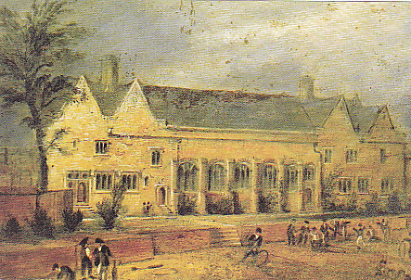

Berkhamsted School ca 1800 [Courtesy of David Pearce]

During the school holidays, Sydney presumably stayed with his family (now with the addition of two half sisters after his father’s re-marriage) in Stoke sub Hamdon. Perhaps it was in roaming over Ham Hill and the fields around the vicarage that he developed his interest in natural science. William Rowland was a strict father and bullied his three sons. He himself was interested in all branches of learning except science. Perhaps Dr Rowland’s interest in science stemmed initially from a desire to rebel against his father’s opinions. On the other hand, the headmaster of Berkhamsted, Dr Fry, was particularly keen on the boys learning science and built laboratories for them at his own expense at a time when most grammar schools were only promoting the classics.

In any event, Dr Rowland won a Science scholarship to Downing College, Cambridge, on leaving Berkhamsted School in 1889. While at Cambridge, he became a prominent member of the Natural History Society. His obituary states, ‘at this time he was keenly interested in almost every department of natural science… he was a real amateur of science in the best sense of that word.’

As well as taking part in natural history activities, he was apparently often to be seen, according to the school magazine, ‘in a birch bark on the silvery waters of the Cam’.

He was obviously not going to be following his father into the church. John Cowper Powys describes him while they were at Cambridge together as being a man who ‘with Epicurus denied the immortality of the soul’.

Sydney Rowland’s rooms in Downing College, Cambridge
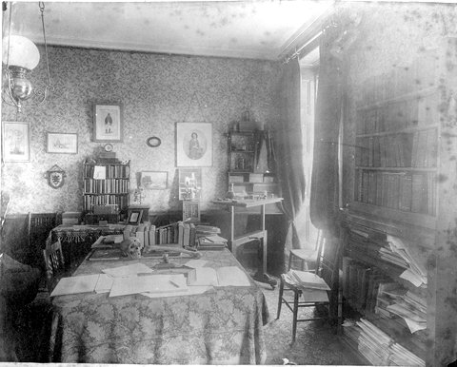

[Photo courtesy of Martin Gibbs – Charles Martin, his life and letters]

After leaving Cambridge, he completed his medical studies at St Bartholomew’s Hospital. X-rays had just been discovered, and he spent much of his time studying their application to medicine. He qualified as a doctor in 1897, then spent two years practising as an x-ray specialist and working on the editorial staff of the British Medical Journal, of which his uncle, Dr Ernest Hart (‘a distinguished and sinister man’, according to Philip Gibbs) was editor. He was not very successful at either of these ventures. Dr C J Martin of the Lister Institute, soon to become Rowland’s boss and good friend, explains, ‘Rowland, although a good and interesting conversationalist, was singularly devoid of any literary faculty, and it was impossible for one of his nature and unbusinesslike habits to remain at his rooms and await the advent of patients.’

In 1898, however, he took up a position which suited his qualities – Rowland became Assistant Bacteriologist at what has, since 1903, been called the Lister Institute, but was at that time the British Institute of Preventive Medicine. The Institute was founded in 1891 and it was therefore a young organization which Rowland was joining. In 1898 the Chelsea laboratories opened and a major donation by Lord Iveagh set the Institute up as a viable organisation. It was the only institute of its kind in the country. H J Bensted, Director of the Public Health Laboratories at Colindale after 30 years in the RAMC, wrote, ‘of course I worked at the Lister – everyone in my generation worked there at some time or other. We Boxed and Coxed out of the Battersea Park flats.’

In the large new building in Chelsea, people were engaged in bacteriology, immunology, virology, physiology, biochemistry and cancer research. Harriette Chick, in her history of the Lister Institute, War on Disease, describes it as being ‘a kind of club, rigid in standards, informal in manner; a little puzzling to strangers, remembered nostalgically by the guests, held in pride and an often exasperated affection by its more permanent residents.’ It was a place where there was the opportunity for the exchange of expert information, and the formation of lasting friendships. A photograph taken of the scientific staff in 1907 shows Rowland with his fellow workers, none of them over 35 years old. Sydney Rowland had found his niche, and remained working for the Lister until his death in 1917.

Rowland had studied microscopy at Cambridge and ultimately his technique became one of the best in the country. His first scientific paper dealt with the structure of bacteria. His scientific investigations were aided by the fact that he was a very good mechanic, enjoying immensely the challenge of overcoming the technical difficulties involved in experiments. In fact, once he had solved a mechanical problem, he very often lost interest in the actual work of the investigation.

In 1905, Dr Martin, Rowland and a shy young Scot called George Petrie went out to Bombay to work upon the Commission for the Investigation of Plague in India. After three years of extensive experiments with hundreds of thousands of dead rats being dissected, the Commission were able to prove that it was the rat flea which was responsible for the spread of plague.

Two years after Rowland’s return to England, there was an outbreak of pneumonic plague in the East Suffolk village of Freston. Four people died. Martin and Rowland were asked by the government to visit the scene and investigate. After catching 700 wild rats and examining the fleas infesting them, two rabbits and a small number of fats wee found to have the plague baccillus, and it was suggested that the rats had escaped from ships travelling from the east.

At the Lister laboratories at Elstree, Rowland worked with the bacillus pestia – the organism of plague – in attempting to make a vaccine against the plague. This organism was extremely dangerous and in 1909 an Australian working under Rowland fell ill. Rowland and his colleague, Hartley, nursed him, thinking it was influenza, but Dr Martin came out from Chelsea and realised that the illness was pneumonic plague. The patient died within three days of falling ill. Hartley was given 50 cc of anti-plague serum in the groin. According to Harriette Chick’s War on Disease, Hartley said, ‘I was frightened to death, and itching so much from the serum, death seemed almost preferable.’ It is not mentioned whether Rowland, too, was given the anti-plague serum. In 1914, therefore, when Rowland volunteered his services and was sent to France in charge of No 1 Mobile Laboratory, he was no stranger to working under dangerous conditions.
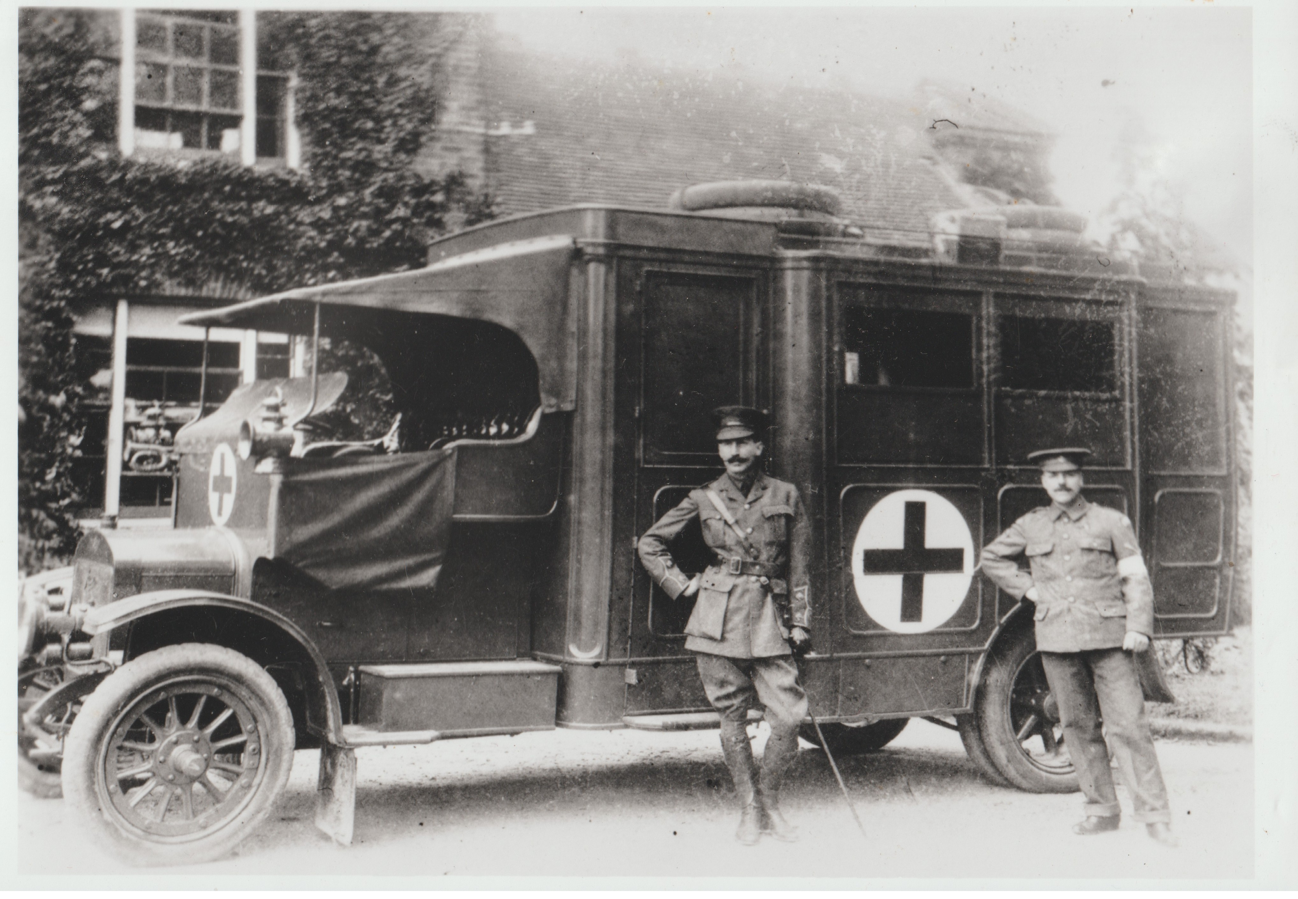

This photograph (courtesy of Wellcome Trust Medical Photographic Library) shows Dr Rowland with his Mobile Laboratory outside Queensberry Lodge at Elstree, where some of the Lister’s bachelor workers were accommodated. Charles Martin writes, ‘to the equipment of this he had devoted much ingenuity, and it served as a model for others subsequently sent out by the War Office.’ One can imagine the enthusiasm with which Rowland set about this task.

He went to France as a lieutenant in the RAMC, and set to work looking for typhoid carriers amongst the troops and the civil population, as well as sending back samples of infected muscle for those scientists still remaining at the Institute to study, in their attempts to find an antitoxic serum for use in the treatment of gas gangrene.

He was promoted to Major in 1915, and in February 1916 he was attached to No 26 General Hospital to study, amongst other things, the treatment of septic wounds. It was while he was discovering carriers of the meningococcus that he contracted the disease himself and died on Tuesday 6th March 1917. He was 45.

Sydney Rowland dedicated his life to science. He was unmarried and the Lister Institute was his home. Was his social life then non-existent? Some of his letters (now held by the Wellcome Institute) written to Dr Martin before the 1st World War belie this. They portray Sydney Rowland bubbling over with excitement about his experiments, spending Sundays visiting friends and relations, taking Miss Chick to London to see Parsifal, and spending time (as I expect many of the young Lister scientists did) at the family home of Charles Martin who gave all his employees the benefit of his inspiration and advice. In the summer of 1914, Rowland was busy organising a holiday trip to Germany in a foursome with Charles Martin and two others.

He writes:

‘My dear Martin – You will get a letter soon from Mrs Jimmy asking you to come on the motor trip. Just we four. Do fix it up, we will have a real good trip. A fine car and Europe at our feet. Cost about 10/- a day or a little more for Germany. The usual programme is to start after breakfast, buy food on route and eat it in a wood for lunch. Get to some place about 4, see the sights, dine and bed..’
[Letter courtesy of Wellcome Institute for History of Medicine]

By August, these plans have had to be abandoned, ‘The blighters have busted up Belgrade so our chance of seeing it has gone’.

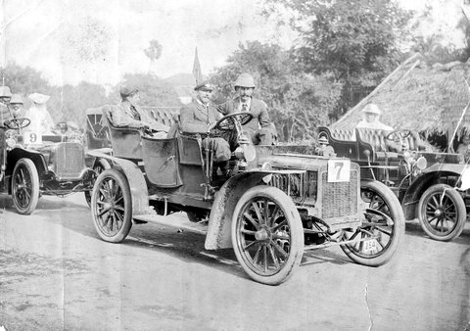

Sydney Rowland, racing – pre-1914

[Photo courtesy of Martin Gibbs – Charles Martin, his life and letters]

The best description of Sydney Rowland is that written by Dr Martin in Rowland’s obituary in the British Medical Journal in 1917. The photograph shows a man with thick dark hair, eyes slightly close together, a large nose and a handlebar moustache framing a humourous mouth.

Dr Martin writes:

‘Sydney Rowland was a cheery, erratic creature, with a vivid zest in life. He had a fine imagination, towards which he was not always sufficiently critical. He was courageous, impulsive, sensitive, generous to a fault, withal casual and thoughtless; but in view of his many sterling qualities, his friends willingly put up with any shortcomings. He was a charming companion, and much beloved by those who knew him well. Especially he endeared himself to all those who had to work under him. He was a great favourite with children, and among those who will miss him most will be the many young people of his acquaintance.’

(Many thanks for their help in the writing of this article to: Dawn Robson – Yeovil Library, David R A Pearce – Editor of Old Berkhamstedian Magazine, Martin Gibbs, Richard Rowland, R L Barrett-Cross – RAMC Historian, Keith Cowey – Lister Institute of Preventative Medicine, Sally Thompson – St Bartholomew’s Hospital.)

